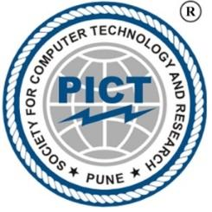 ** **

**SOCIETY FOR COMPUTER TECHNOLOGY AND RESEARCH**

**PUNE INSTITUTE OF COMPUTER TECHNOLOGY**

Entrepreneurship Development Cell & Business Incubation Centre

Startup and Innovation Cell

**_____________________________________________________________________________________**

**Vision**

PICT Startup and Innovation Cell aspires to be a leader in creating an encouraging ecosystem and culture for Startups, Innovation by conducting creative activities and contributing to the economic growth and social advancement of the nation**.**

**Mission**

To be a leading institute in developing a culture of Startup and innovation and providing an environment for aspiring Entrepreneurs by engaging students in activities such as Sharing Ideas, Experience , Networking, Mentoring , Innovation and Incubation of startups.

**Short Term Goals**

1. Planning of entrepreneurial activities on a monthly/quarterly basis to create awareness among students about innovations and startups.
2. Developing and guiding potential inhouse startups to reach out to substantial mentors, customers and fulfill goals.
3. Collaborating and Networking with various Entrepreneurship Groups to increase exposure and build greater breakthrough products.
4. Providing a boost to social and public projects, in turn benefiting society and the country.

**Long Term Goals**

1. Promote effective entrepreneurial skills like Innovation, Productive Entrepreneurship and Economic Growth.
2. Contribute to economic development and Global Innovation Index through well established startups.
3. Provide an environment to nurture and encourage innovative potentials for startups.

**About Entrepreneurship Development Cell (EDC)**

* The PICT EDC aims towards guiding students and providing them with a platform for developing their **entrepreneurial skills**.
* It is a cell run by the students for the students. It not only motivates the students but also provides them with the necessary resources including guidance, mentoring and incubation.
* EDC conducts various activities such as workshops, interactions with entrepreneurs, case studies, building prototypes, etc. to cultivate various skill sets like **organizing, team building, sales and marketing, relationship building, getting exposure to the real life marketing challenges and analyzing the new marketing trends** etc. which is a really important part of start-ups.
* PICT EDC was inaugurated on 4th March, 2009.

**About Business Incubation Center (BIC)**

* The business incubation center is a platform where we provide guidance for the business startups and also provide various services and facilities like high configuration systems, high speed internet, office space, and other resources etc.
* Till now 18 startups have been incubated in this Incubation Centre. The one which is being incubated right now is the Gauss and Reimann Scientific which is now ChiStatsPvt.Ltd.
* The first company ‘Anchanto’ was also incubated the same year, which is now a very successful company.

**About Startup and Innovation Cell (SIC)**

Objectives of the Cell:

1. The Startup and Innovation Cell provides a platform to those ideas which has a great potential to become a successful product or a Service.

2. The ideas should lead to Startup and Entrepreneurship.

3. The idea should promote Project Based Learning.

4. Products/Services should solve the existing Social Issues.

5. To develop a Healthy Startup and Innovation Ecosystem.

**Activities Performed in 2020-21**

**1. Companies Incubated in EDC**

1. **DUKES INN LLP**
2. **SACRED ODYSSEY SERVICES PVT LTD**
3. **ASTROPHEL AEROSPACE**
4. **MIBAIO ELMEC SMART AUTOMATIONS PVT LTD**

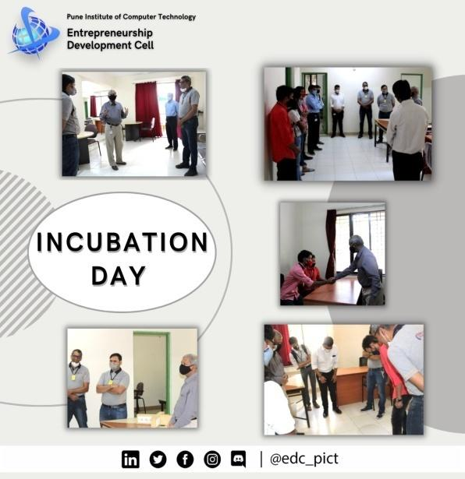 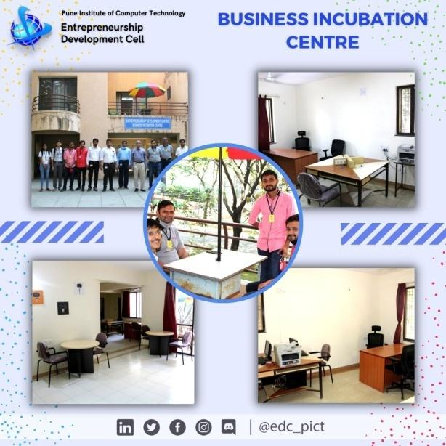

**2. NISP Implementation at PICT**

* The National Innovation and Startup Policy 2019 for students and faculty of Higher Education Institutions (HEIs) will enable the institutes to actively involve students, faculties and staff in innovation and entrepreneurship related activities.
* This framework will also facilitate the Ministry of Human Resource Development in bringing uniformity across HEIs in terms of Intellectual Property ownership management, technology licensing and institutional Startup policy, thus enabling creation of a robust innovation and Start up ecosystem across all HEIs.
* Website developed: <https://edcpict.github.io/EDC_Website/index.html>

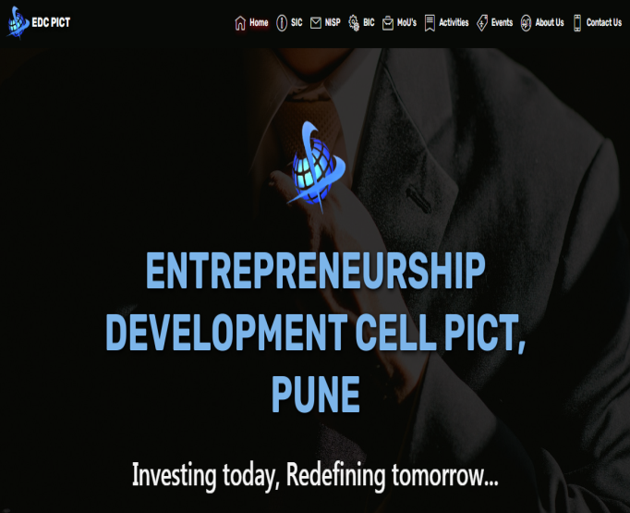 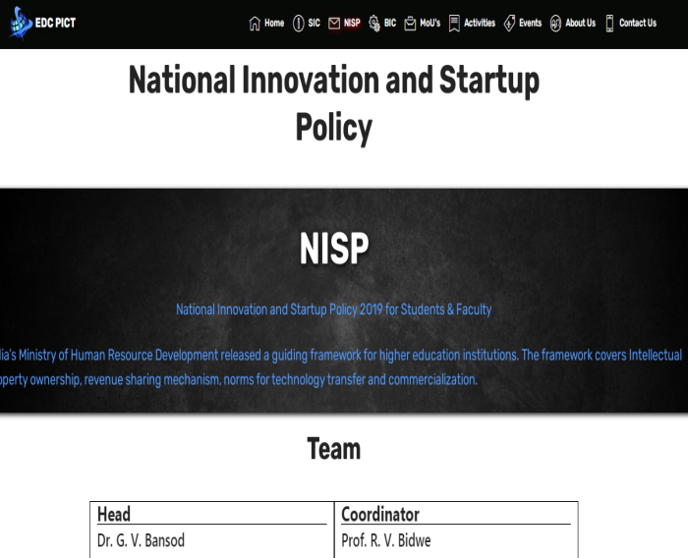

**3**. **Institute Innovation Council at PICT**

**Benefits to Institute, Faculty members and Students**

* Students/Faculties associated with IIC get an opportunity to participate and explore their ideas in events organized by MHRD
* Opportunity to meet Business leaders
* Opportunity to nurture business idea and convert it into prototype by getting seed funding by various agencies
* Mentorship by industry professionals

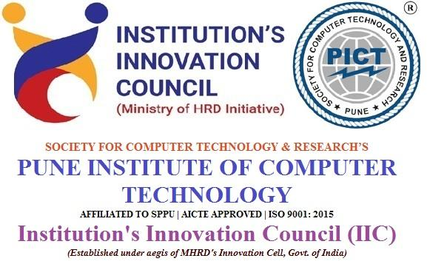

**4. Events organized**

**Following are the activities conducted in AY 2020-21**

|  |  |  |
| --- | --- | --- |
| Sr. No | Name of Event/Activity (Full Name) | Speaker |
|  | EDC Orientation | EDC members |
|  | Sources of Passive Income | Mr. Nikhil Jain |
|  | The Original Pitch | Navayuvak Entrepreneurs |
|  | Stock Market Series Inaugration | Mr.Omkar Phadatare |
|  | The Right Way to Pitch Investors | Mr. Mahavir Sharma. |
|  | Mind Mapping | Mrs.Trups Sawant |
|  | Go to Market Stratergy In New Normal | Mr.Deakin Daney |
|  | Digital Marketing And Its Subdomain | Mr.Dhaval Gundecha and Mr.Sanyam Chhoriya |
|  | Prototype Development Workshop | Mr. Prashant Joshi |
|  | The First Person | Mr. YASH SHUKLA |
|  | Start a Venture while in College | Mr.Aditya Shirole |
|  | Hardware security and Hardware wallets | Mr.Rohan Agarwal |
|  | Inception The Headstart | Mr.Nikhil Jain |
|  | Product Development | Mr.Kartik Natarajan |
|  | Session on Stock Market | Mr.Deepak Agarwal |
|  | Primary Markets | Mr.Deepak Agarwal |
|  | The Neeed To Invest | Mr.Deepak Agarwal |
|  | Stock Market Session for trading platform and basics of charts | Mr.Deepak Agarwal |
|  | IPR & IP MANAGEMENT FOR START UP | PROF.SURAJ S BHOVAR |
|  | Building Minimum Viable Product | Mr. Siddharth Malani,  Mr. Prashant Joshi,  Mr. Ashwin Bhandari |
|  | 5 minute pitch competition | Dr.Prahlad Kulkarni,  Dr. Sunil Patil,  Mr.Sandeep Bhat,  Mr Shaliesh Vaidya,  Dr.Sachin Wadikhaye, Mr.Mahaveer Muttha,  Mr.Ismail Akbani |
|  | Angel Investment and vc funding | Mr.Sahil Sharma |
|  | Prototype Validation | Mr.Mahaveer Mutha |
|  | A session on Product Innovation. | Mr.Ashok Saraf |
|  | Session on Intellectual Property and IP Management | Mr. A. M. Deshmukh |
|  | Doing Innovations For Social Good | Mr. Ashwin Chaudhari,  Mr. Gaurav Bansod |

**5. Information and Glimpses about the events**

**The Original Pitch**

* **Step in with an idea, Step out with a Startup...**

**The Original Pitch** is an event which encourages the young mind to brainstorm toward real life problems that exist around them through their Innovative thinking. This event will give a platform to all such young minds and encourage them to continue to innovate and contribute to the ecosystem of innovation. Event is started from 29th October 2020.

* **THREE PHASES:**

1. Actionable Entrepreneurship Program

2. Innovation Challenge – Original Pitch

3. Virtual Incubation Program

* **Registration count: 400+, across India.**

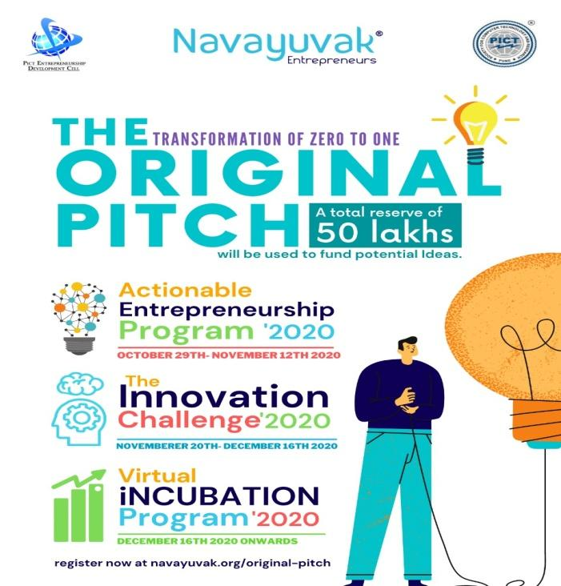 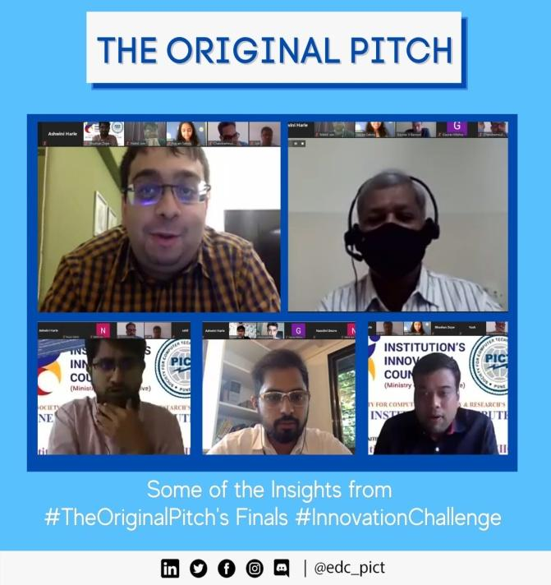

**Pitch-in-Five:**

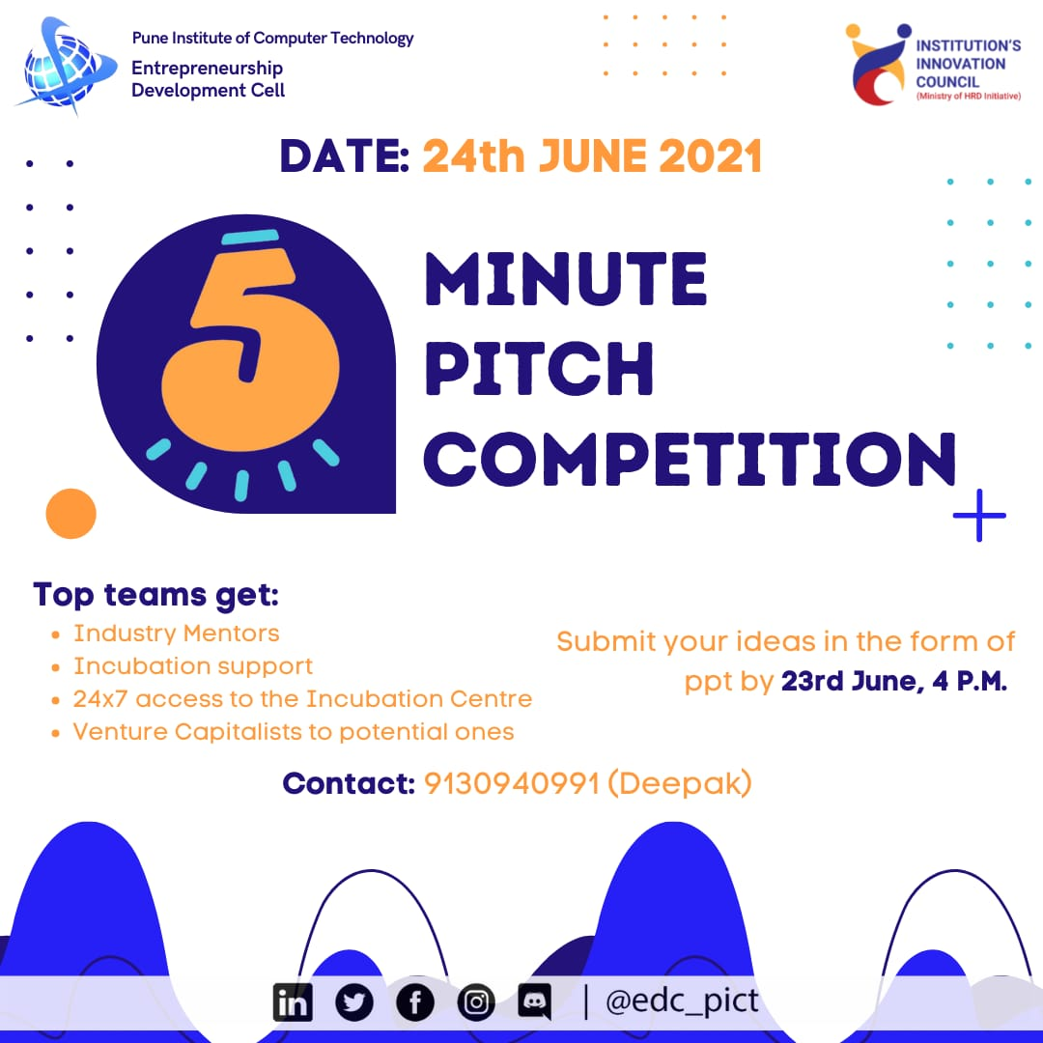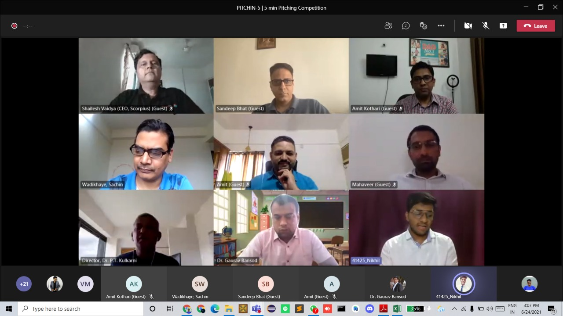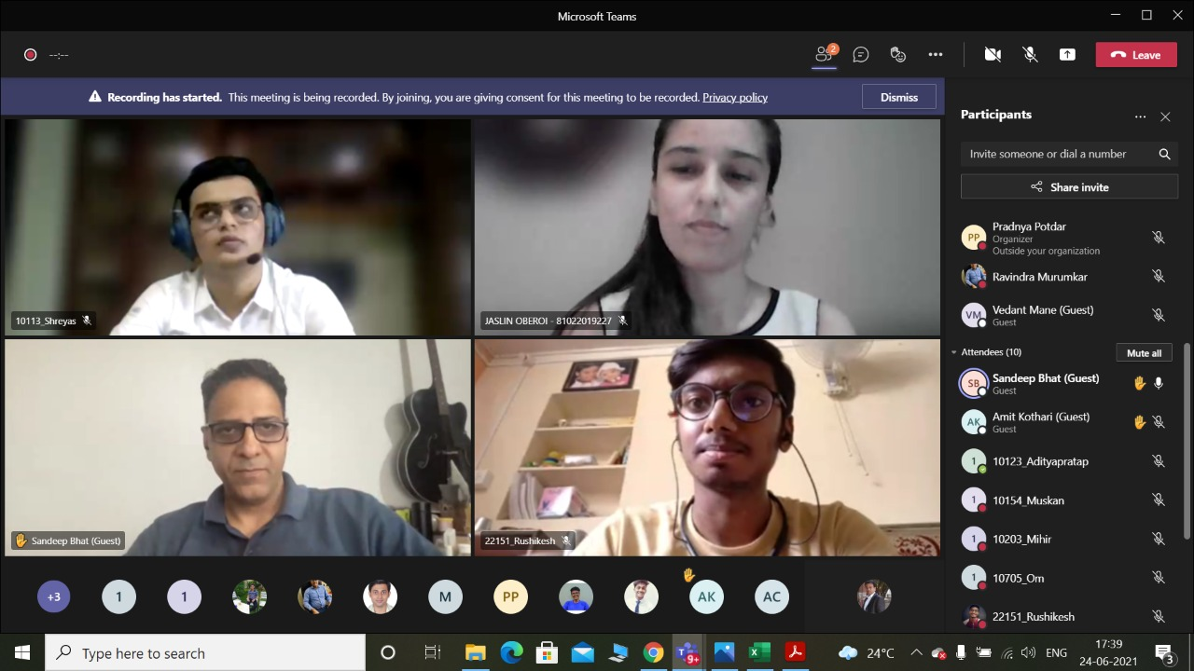

**Incubation Interviews**

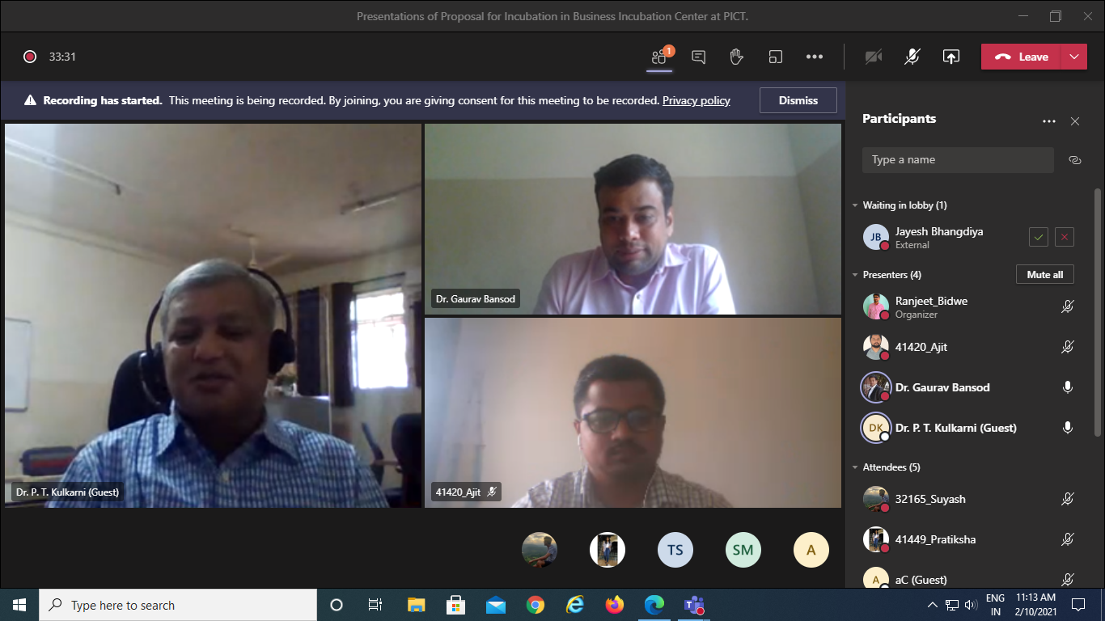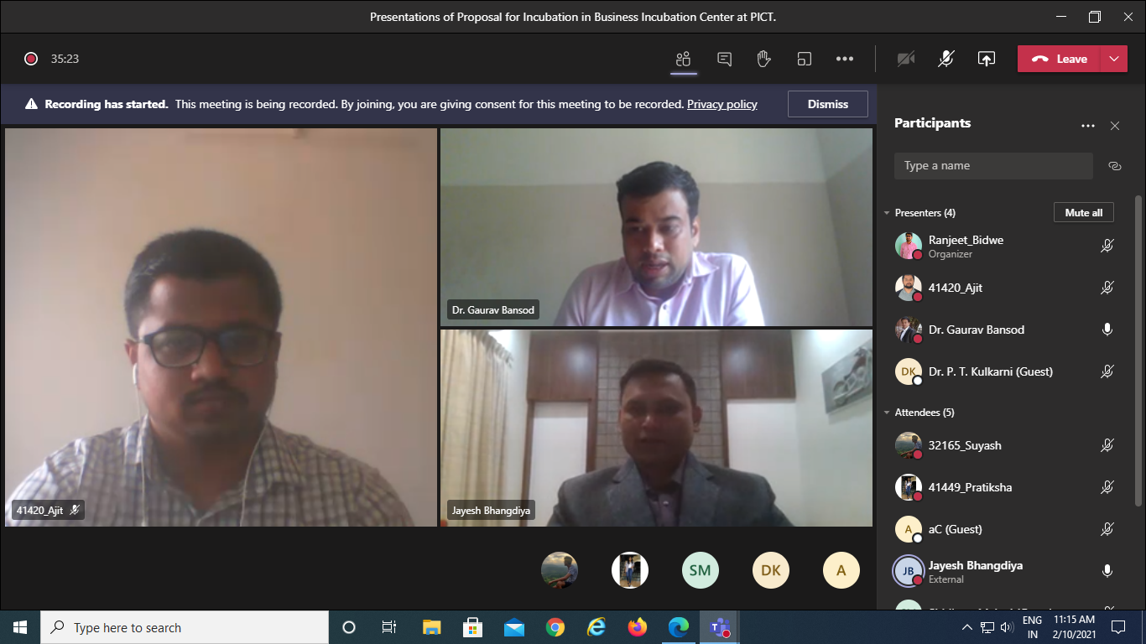

**6.Product Development**

**Temperature-face Mask Detector**

System initially scans barcodes from the ID of an employee, Next the same camera is used to detect if the person is wearing a mask or not. This is done with the help of image processing and haar-cascade to give efficient and real time output. A temperature sensor MLX-90614 is then used to monitor the temperature of the person and map it to the corresponding barcode which is read.

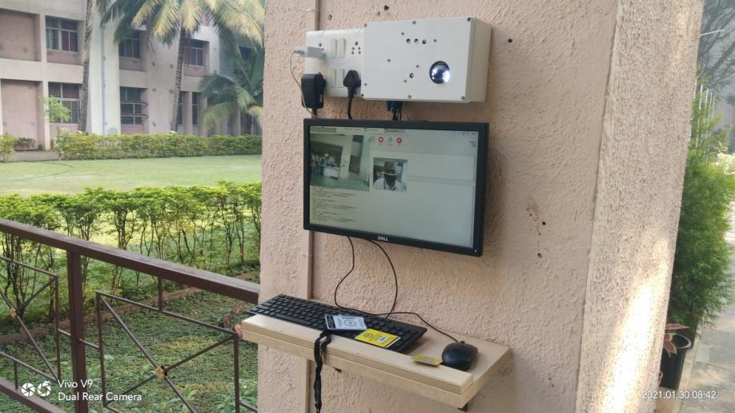

**SPPU i-2-e Competition 2020-21**

Two innovative projects are nominated to SPPU by the cell.

1. Anti Covid net
2. Due Date

 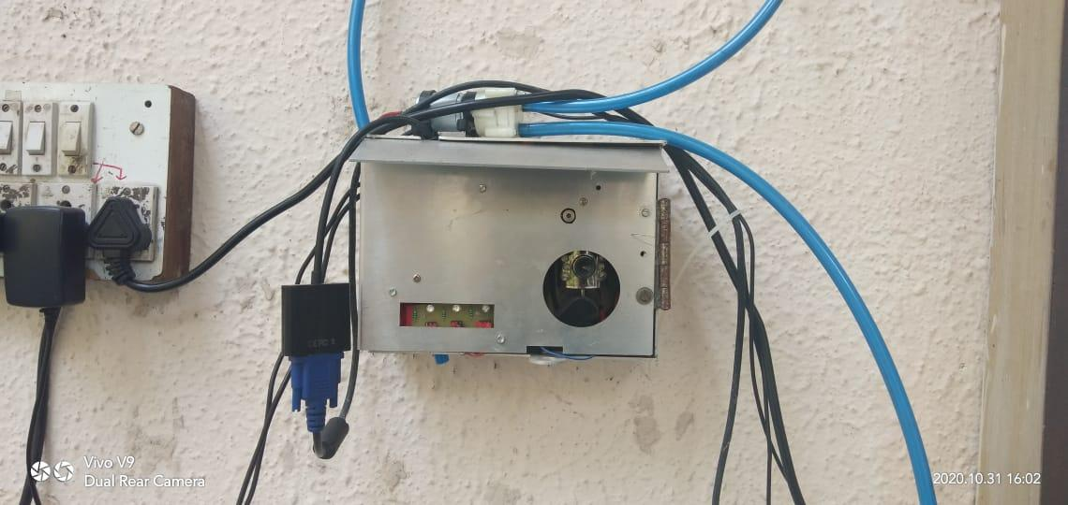

**Event Posters:**